**SMART WATER MANAGEMENT**

|  |  |
| --- | --- |
| **Date** | **04-10-2023** |
| **Team ID** | **536** |
| **Project Name** | **Smart water management** |

**Table of Contents**

|  |  |
| --- | --- |
| 1 | Introduction |
| 2 | Problem Statement |
| 3 | Design and Innovation Strategies |
| 3.1 | Micro Controller Selection |
| 3.2 | Sensors Selection |
| 3.3 | Connectivity |
| 3.4 | Cloud Platform |
| 3.5 | Protocol |
| 3.6 | Public Platform |
| 4 | Conclusion |
|  |  |

**1. Introduction**

Smart Water Management (SWM) uses Information and Communication Technology (ICT) and real-time data and responses as an integral part of the solution for water management challenges. SWM is becoming an area of increasing interest as governments from around the world integrate smart principles into their urban, regional and national strategies. The potential application of smart systems in water management is wide and includes solutions for water quality, water quantity, efficient irrigation, leaks, pressure and flow, floods, droughts and much more.

By applying SWM infrastructure such as sensors, smart meters, monitors, GIS and satellite mapping, and other data sharing tools to water management, real-time solutions can be implemented and broader networks can work together to reduce current water management challenges.

**2. Problem Statement**

The current water management system in our region suffers from inefficiency, water losses, and a lack of real-time monitoring. The objective is to design, develop, and implement a **“Smart Water Management”** System that addresses these challenges by optimizing water distribution, reducing water wastage, enhancing system resilience, and promoting responsible water use."

**3.Design and Innovation Strategies**

#### 3.1. *Micro Controller Selection*

For a Smart Water Management system using IoT, consider using a microcontroller like Arduino or Raspberry Pi. Arduino offers simplicity and low power, while Raspberry Pi provides more processing power for data analysis. Integrate sensors like water level detectors and rainfall sensors with IoT modules (e.g., ESP8266 or SIM800) for connectivity. Use a cloud platform such as AWS or Azure to process and analyze data, triggering alerts for early warnings. Remember to prioritize power efficiency and robust communication for reliable operation in remote areas.

#### 3.2. *Sensors Selection*

For a Smart Water Management system using IoT, opt for water level sensors with real-time data transmission capabilities. Ultrasonic or pressure sensors are commonly employed to gauge water levels. Connect these sensors to an IoT platform for continuous monitoring. Ensure the system sends alerts based on predefined thresholds to enable timely warnings. This sensor selection facilitates swift response and helps mitigate the impact of floods.

The volume of water in the RS, whether imported or extracted, is divided into billed water (BW) and NRW and even between controlled and uncontrolled consumption. The billed water is the consumed water that is directly charged to customers. The NRW is the volume that includes the water losses and the consumed volume by the authorized agents (e.g., social services, fire-fighting services). A simplifying schematic of this water balance is shown in Figure.

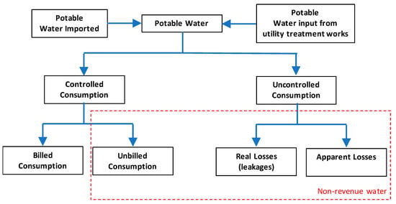

[**Figure**](https://www.mdpi.com/2073-4441/12/1/58#fig_body_display_water-12-00058-f002)**: Distribution of water balance**

**3.3. Connectivity**

If water is flowing continuously than the expected time then it will be detected by water flow sensor and data will go to IOT server. User can see the real time data in IOT server and in this condition one notification will be sent to mobile App from IOT server. If the water PH level or dirt level is not good then the water will not be pumped into the tank. User can control water flow through mobile app by interacting with the server.

Overall design ie, System architecture is represented in Figure 1, which provides information of about how the components are interconnected and how components interact with each other. Sensors are placed in storage tank and overhead tank. In overhead tank three sensors are placed indicating levels of water along with these sensors PH sensor is also placed for checking purity.

Any impurities present in storage tank are detected by using image processing concept. Pi camera module will capture the images and sends to server. Server will process the image and determines the status as either pure water or dirty water and then sends to the user android/mobile application. It also notifies the same to the user. The water from the water tank and in sump is monitored through android application via server connection. Presence of impurities in storage tank is detected by using image processing concept with Pi camera module.

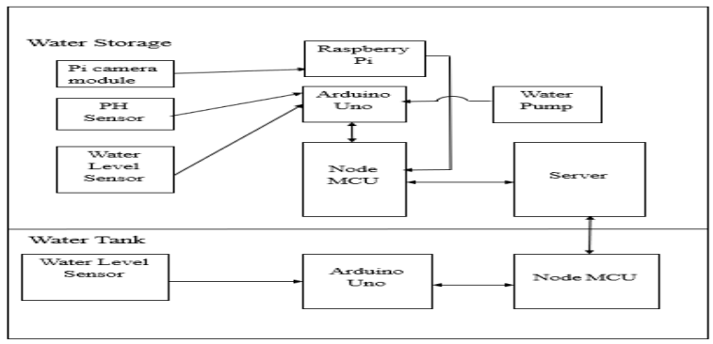

**3.4. Cloud Platform**

For Smart Water Management systems using IoT, AWS (Amazon Web Services) is often a popular choice. Its scalable infrastructure and various services make it suitable for handling the data generated by IoT devices, analysing it in real-time, and triggering alerts or warnings. AWS IoT services, along with data storage and analytics tools, can be seamlessly integrated into a comprehensive Smart Water Management System.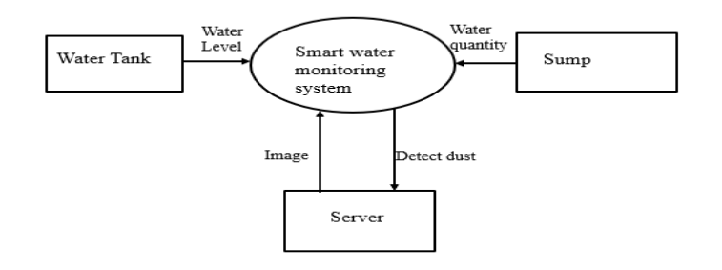

**Figure: Methodology and Implementation of Smart Water Management Systems**

**3.5. Protocol**

IoT-based Smart Water Management systems often utilize the MQTT (Message Queuing Telemetry Transport) protocol for efficient and real-time communication between sensors and the central monitoring system. MQTT's lightweight and publish-subscribe architecture make it ideal for transmitting data such as through the continuous analysis of sensor data, smart water systems can identify trends, assess the condition of infrastructure components, and predict maintenance needs.

This proactive approach to infrastructure maintenance extends the lifespan of critical assets, reduces the frequency of costly repairs, and ensures the consistent performance of the water distribution system. By optimizing infrastructure management, water utilities can allocate resources more efficiently, saving both time and financial resources. The synergy between real-time alerts and infrastructure optimization is a cornerstone of effective smart water management, ensuring the reliability, sustainability, and cost-effectiveness of water distribution networks while safeguarding the quality of water services for communities and consumers.

**3.6. Public Platform**

One notable public platform for Smart Water Management systems utilizing IoT is the Smart Water Management systems (SWMS) developed by the government in collaboration with IoT technology providers. It integrates sensors placed in water management areas to collect real-time data on water levels. The information is transmitted to a central platform, analysed, and disseminated through various channels, including mobile apps and online platforms. This enables timely alerts and helps communities, authorities, and individuals make informed decisions to mitigate the impact of water, showcasing the power of technology in enhancing disaster preparedness and response.

**4. Conclusion**

Smart water management is the use of digital technologies to improve the efficiency and sustainability of water management. It involves the use of sensors, data analytics, and artificial intelligence to monitor and control water systems in real time. smart water management can also have a broader impact on the environment and society. For example, smart water management can help to reduce greenhouse gas emissions, conserve ecosystems, and improve public health. Overall, smart water management is a promising approach to improving the way we manage water resources. Despite the challenges of cost, data security, integration, and public acceptance, smart water management is a promising approach to improving the way we manage water resources. Smart water management is a vital tool for addressing the global water crisis. By investing in smart water management systems, we can improve the efficiency and sustainability of water management and ensure that everyone has access to clean water.